You do not have to wait until the 25th , Please just call or go to their website and submit form
House
Representative Blake Moore – 202-225-0453
Representative Celeste Maloy – 202-225-9730
Representative John Curtis – 202-225-7751
Representative Burgess Owen – 202-225-3011

Senate
Senator Mitt Romney – 202-224-5251
Senator Mike Lee – 202-224-5444

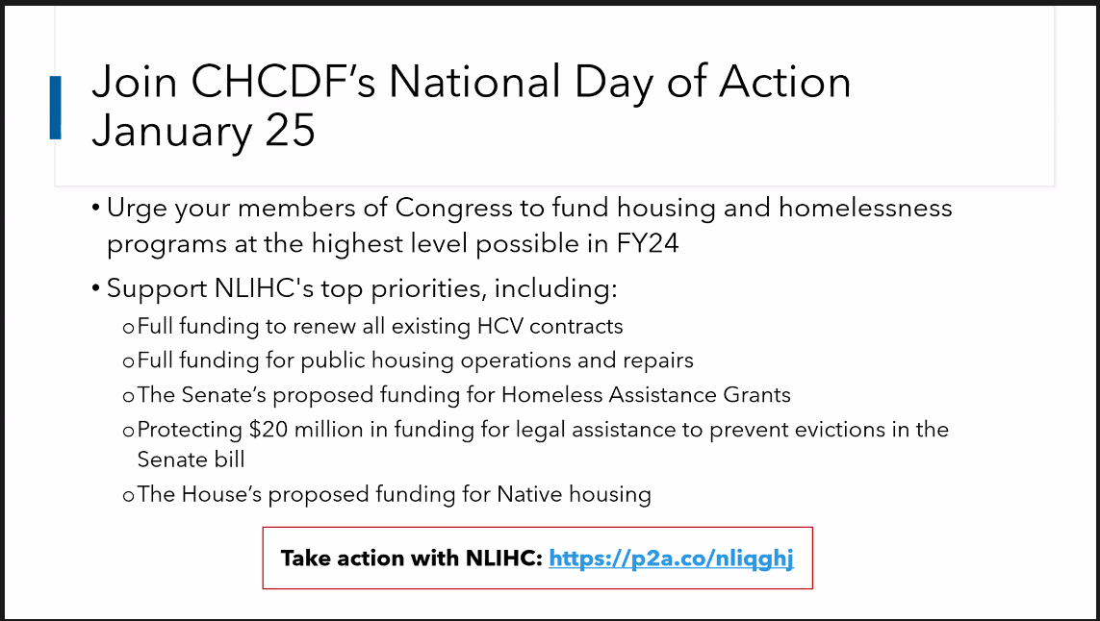
Or Easier Go to -
https://p2a.co/nliqghj
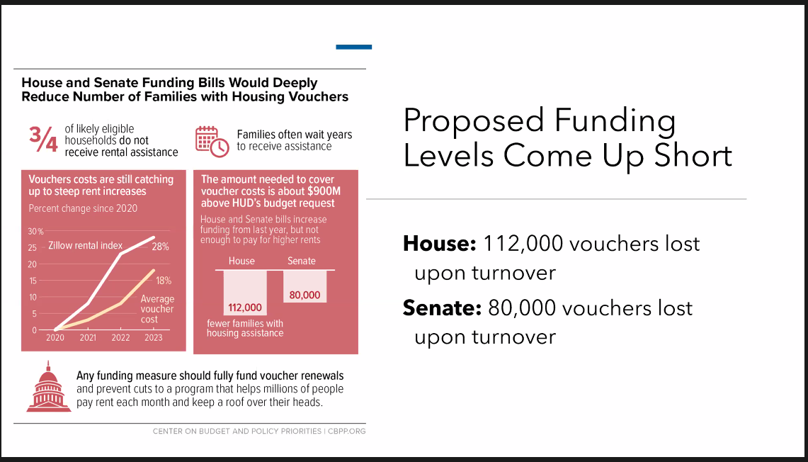

Let’s Make a Difference!
Because Housing Matters

